## 5th Woodley Est 1974

## Welcome to 5th Woodley Scout Group

The following pages are intended to give you all the necessary information to get your child started in scouting. If you have further questions which are not answered here, then please do not hesitate to contact one of the Scout leadership team:

**Where do we meet?**

The Sports Hall, Waingels College, Waingels Road, Woodley, Berkshire, RG5 4RF

**Drop off:**

Enter the main car park. If the black gates (indicated in red) ahead by the nursery are open, you can go through and park in the car park in front of the sports centre (the building to the left of the blue football pitches). If the gates are closed when you need to exit, they will auto open for you. If they aren’t open, park up in the main car park and walk across the quadrant towards the sports centre (shown by the blue line). The entrance to the sports centre is to the left of the blue football pitches, at the end of the blue line. Once inside, proceed down the long corridor to the hall at the end – straight in front of you.

## The Aim of Scout Movement

The aim of The Scouts has been the same for over 100 years, which is to encourage the physical, mental and spiritual development of young people so that they may take a constructive place in society. However, over the years, the Scout movement has continued to grow and evolve with the world around us whilst upholding its founding principles. Today it is fully inclusive and offers an enjoyable and attractive scheme of progressive training for boys and girls based upon a Law and Promise and to develop skills for life. All activities are age appropriate and guided by adult leadership who are appropriately trained and vetted. We now have over **102,000 girls** and have started 834 sections in areas of deprivation since 2013

## Squirrel Scouts

At Squirrels, 4 and 5-year-olds for both boys and girls will have fun outdoors, learn new skills with friends and earn badges through fun activities.

This is an age when minds are fizzing, when energy and curiosity levels are sky-high, when little lives are full of wow and wonder. Set them climbing the tree. Who knows how far they’ll reach? But we’ll need your help to make this all happen.

## Drey Meetings

Drey meetings take place on **Monday** and **Thursday** evenings from 17:30 – 18:30 **at the sports hall, Waingels college.** Squirrels are asked to arrive shortly before the start time in order that the meeting can start promptly. All Squirrells should be collected at the end of the meeting. If you come into the hut 5 minutes before the end you will see the closing ceremony.

## Beaver Scouts

Beaver Scouts are in the age range 6 – 8 and is for both boys and girls. They are collectively known as a Colony and take part in a wide range of activities including games, crafts, singing, visits and good turns, along with outdoor activities. They will also have the opportunity to take part in the fun and excitement of camps and sleepovers. It may be the first time they spend a night away from home so it’s a real adventure for them.

## Colony Meetings

Our Colony meetings are currently held every **Tuesday and Wednesday** during school term from **17:45 – 18:45** **at the sports hall, Waingels college.** On occasion we may meet elsewhere or on a different night, however prior notice will always be given. Note that **Wednesday** Beavers may meet at 2nd Woodley’s scout hut in Vauxhall Drive, almost opposite Austin Road. Beavers are asked to arrive shortly before the start time in order that the meeting can start promptly. All Beavers should be collected at the end of the meeting. If you come into the hut 5 minutes before the end you will see the closing ceremony.

## Cub Scouts

Cub Scouts are aged 8-10 ½ and is for both boys and girls. Every week, they gather in groups called **Cub Packs** to take part in lots of interesting and challenging activities – achieving anything they set their minds to and having lots of fun along the way.

## Pack Meetings

Our packs meetings are currently held every **Tuesday** and **Thursday** during school term from **19:00 – 20:30 at the sports hall, Waingels college.** On occasion we may meet elsewhere or on a different night, however prior notice will always be given. Cubs are asked to arrive shortly before the start time in order that the meeting can start promptly. All Cubs should be collected at the end of the meeting. If you come into the hut 5 minutes before the end you will see the closing ceremony.

## Scouts

Scouts are aged from 10 ½ to 14. Each week they gather in groups called **Troops** to master new skills and try new things to conquer the small task of changing the world

## Troop Meetings

Our packs meetings are currently held every **Monday** and **Wednesday** during school term from **19:00 – 21:00 at the sports hall, Waingels college.** On occasion we may meet elsewhere or on a different night, however prior notice will always be given. Note that **Wednesday** Beavers may meet at 2nd Woodley’s scout hut in Vauxhall Drive, almost opposite Austin Road. Scouts are asked to arrive shortly before the start time in order that the meeting can start promptly. All Scouts should be collected at the end of the meeting. If you come into the hut 5 minutes before the end you will see the closing ceremony.

## Leadership

The sections are run by a section Leader and at least one Assistant Leader or occasional helper. All leaders are **volunteers** who give their time for **free** and receive training for their role. The Leaders are responsible for planning and running a programme of activities and games at meetings and special events. All of the leaders and assistant leaders are given names which the children use to address the leaders. At 5th Woodley we all have names associated with birds but this varies from group to group.

We really want to get more leaders involved in these groups. You don’t need any scouting history. Many describe it as the best non paid job! You get to have fun with your adult head on. It’s a truly inspiring role and it a chance to give something back to the community. You don’t need to commit to every session so the more leaders we have the easier it is to run.

## Occasional Help

Adult assistance in running any of our activities would be greatly appreciated, whether it is on a regular or occasional basis, or perhaps you have some skills which you would like to share. If you are willing to help or have skills that could help in an activity, then please let us know. You don’t need to organise or plan anything. Just be on hand to help out in any way you can.

**DBS (Disclosure Barring Service)**

Due to the national Child Protection Act, any adult who comes into contact with any child within the 5th Woodley Scout Group environment has to be what is called, “DBS checked”. This means a police check to make sure that no-one we let near your children has anything on record which might mean they could put your child at risk. We’re sure that plenty of you may have already come across this at work or perhaps other leisure activities and appreciate that we have to do this to ensure the safety of your child - something we all care deeply about.

We can support your through this check if you want to help out. Speak to one of the leaders and they can provide you with the forms.

## How do I pay?

We ask all parents to pay by Direct Debit. There is a one-off **£10** joining fee which includes the cost of a group T-shirt, Necker and Badges, and then a termly subscription of **£50** taken on 31st September, 30th January and 31st May each year. We only need payment once your child has confirmed they want to join us.

**Please note that it is the parent’s responsibility to cancel the Direct Debit when their child leaves the Group. No refunds will be given for overpayment. Please advise the section leader if your child stops attending.**

We will send you a link via OSM (Online Scout Manager) to set up your access to your child’s records and to set up your Direct Debit and Gift Aid declaration (for UK Tax Payers).

**Gift Aid** allows to claim 25p for every £1 of subscriptions from HMRC, **at no cost to yourselves. If you are registered for UK tax, please complete the Gift Aid section on OSM.**

Please provide a primary and secondary contact where possible. We ask that you let us know of any changes to emergency contact details or any changes in your child’s medical details.

The subscription covers:

* Membership to the Scout Association, which includes insurance when participating on Scouting activities.
* Purchase of equipment and materials required to run meeting activities.
* Up keep and maintenance of the hut.
* Purchase of materials for activities (craft, food, cooking items etc)

Additional optional activities may be subject to a separate cost to fund the event (e.g. camp).

## Training Scheme and Badges

The Beaver Scout training scheme is based on a set of challenges which covers a variety of age-appropriate skills across the programme areas of Teamwork, Skill, Global Awareness, Outdoors, Adventure and a Personal Challenge. There is a separate challenge badge for each of these and on completion of all the challenges a Beaver will be awarded the Chief Scouts Bronze Award, which is the highest award in Beaver Scouts.

In addition to the challenge badges, Beavers can also earn a wide range of activity badges for participation and showing proficiency in a range of skills or activities.

[Badge Link](https://members.scouts.org.uk/supportresources/search/?cat=11,18)

**Online Scout Manager**

All of the administration and notification of events is done through Online Scout Manager. You will be sent a link and you can monitor your scout’s progress. It is essential you check your personal details and emergency contact details. If your child has any health care conditions, please discuss this with the leader.

**Uniform**

All Scouts, whichever section wear a practical smart uniform along with the Group neckerchief and a woggle (yellow and black for 5th). Where smart dress is required, the uniform top can be used with school trousers/skirt and black shoes. Additional optional uniform items are available from the shop. When you first join the group we will provide you with our 5th Woodley Tshirt.

Uniform can be purchased from [**1st Woodley Scouts**](http://www.loddondistrict.org.uk/index.php/district-shop/)**, The Close, Southlake Crescent, Woodley RG5 3QL.**  It is open on **Thursdays: 16:00 to 19:00** and **Saturdays: 10:00 to 12:00**. Payment via card is preferable. This shop is staffed by volunteers and 5th Woodley get a dividend, based on the sales to our Group members. All profits from the shop are fed back into Scouting and returned to the Scout Groups based on their share of trade. 5th Woodley stock a small range of branded items which are useful camps and attendance at scouting events.

We recommend that you obtain a larger size uniform than you normally would to allow it to fit throughout your child’s time in the section. Our group neckerchief is supplied by us, as well as all the badges your child will need, however any replacements will have to be paid for.

The illustrations below shows the positioning of the badges on the uniform:

**Squirrels**

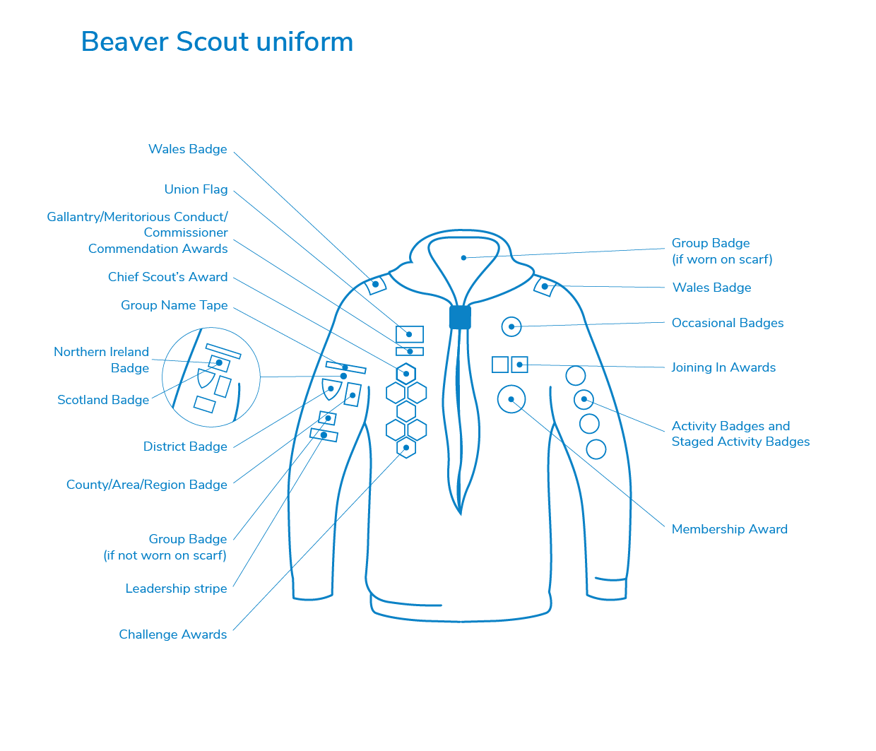

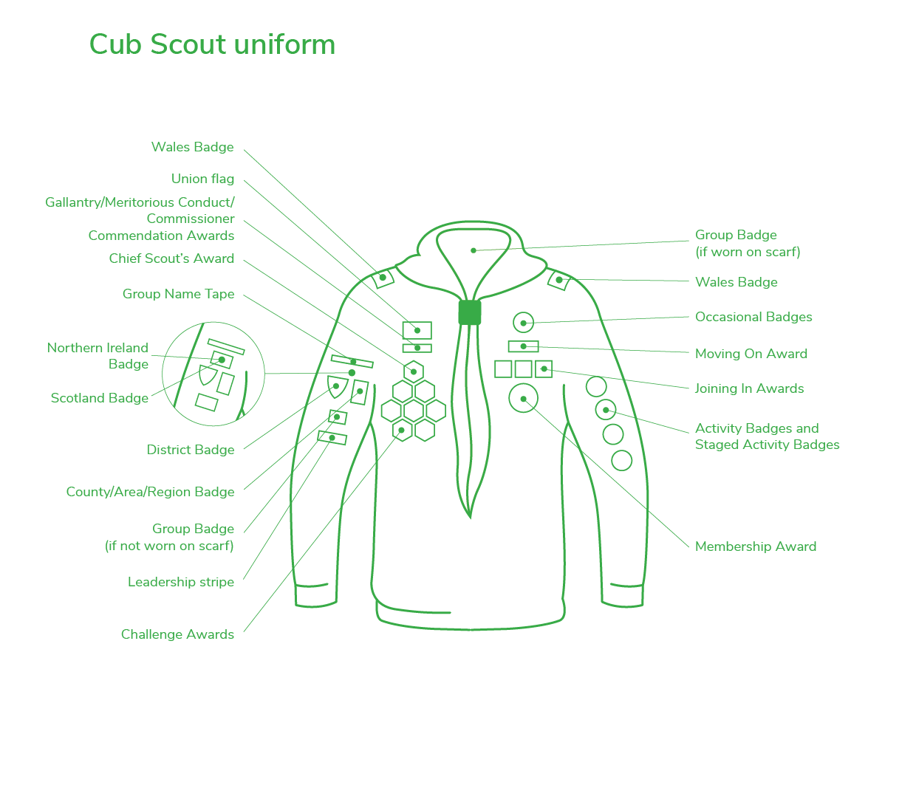

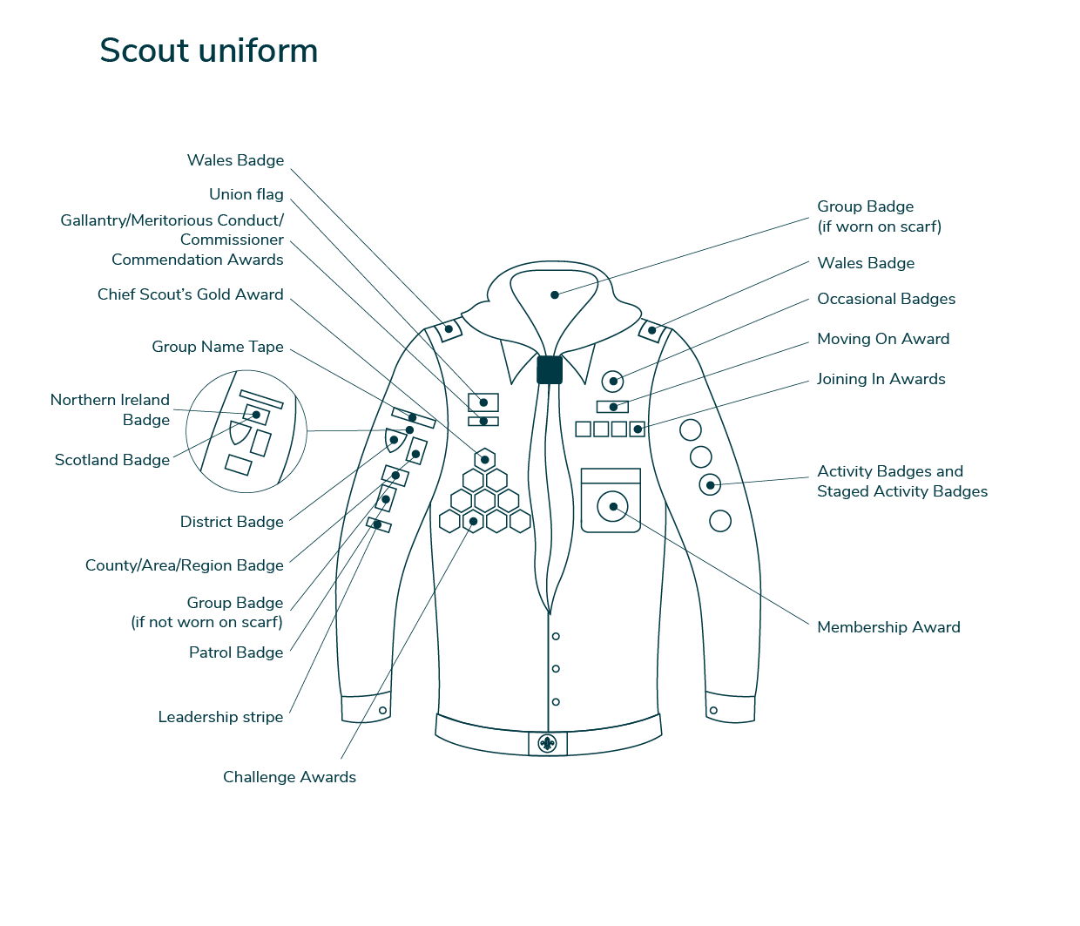

## Investiture

After attending your section for a few weeks, new members will be invested. This is a short ceremony where they will be presented with their Group neckerchief and badges. As part of the ceremony the new member will make their **Promise**, as shown below, which along with the **Scout Motto**. They do not need to memorise this as leaders will help them.

The **Squirrel Scout Promise** is as follows:

**I promise to do my best**

**To be kind and helpful**

**And to love God**

The **Beaver Scout Promise** is as follows:

|  |  |
| --- | --- |
| **I promise to do my best,**  **To be kind and helpful,**  **And to love God.** |  |

The **Cub Scout Promise** is as follows:

|  |  |
| --- | --- |
| **I promise that I will do my best**  **To do my duty to God and to the King**  **to help other people and to keep the Cub Scout Law** |  |

The **Scout Promise** is as follows:

**On my honour,**

**I promise that I will do my best**

**To do my duty to God and to the King**

**To help other people and to keep the Scout Law**

There are also variations of the various Promises to reflect the range of faiths, beliefs & attitudes, and nationalities, in the UK within Scouting (The Scout Association is an open Association and does not identify with one faith exclusively)

The **Scout Motto** is:

**Be Prepared!**

## Keeping Their Promise

Once members have been invested and made their promise, they are expected to keep it at home and at section meetings. However, there are a few things that parents can do to help their child to keep their Promise, do their best and getting the most out of Scouting:

* Turn up to section meetings on time (preferably 5 minutes before the start time) looking clean and smart.
* Endeavour to attend St George’s Day Parade – St George is not only the patron saint of England but also the patron saint of all Scouts.
* Participate in the opportunities, activities and camps we offer.

## Personal Information

As part of administering the various sections it is necessary for the Scout Group to store personal data about the members, their parent(s)/guardian(s) and any additional emergency contacts, along with relevant medical information and any additional needs of the member. This is held in a secure membership database where we also record badge progress and awards made.

As part of our membership records service, we offer a parent login to ensure your personal data is accurate. This will be issued soon after a member joins a section.

**Moving on to Beavers.**

Between the ages of 5½ and 6½, it's usually time for Squirrels to move up to Beaver. Here's what to expect when the time comes.

By moving on to Beavers and going to some meetings, Squirrels can earn one last badge: the Squirrel Scouts Moving On Award.

This can help support those who are getting ready to say goodbye to their section.

**Moving on to Cubs.**

Beavers usually move up to Cubs aged 8 years. Hopefully you will have completed all your challenge awards, so you can be presented with your prestigious Bronze Award.

If you complete 4 weeks at both Beavers and Cubs, you will receive your Beavers ‘moving on’ award.

There is a short ceremony to celebrate the beavers being pulled up to cubs.

**Moving on to Scouts.**

Cubs usually move up to Scouts aged 10 ½ years. Hopefully you will have completed all your challenge awards, so you can be presented with your prestigious Silver Award.

There is a short ceremony to celebrate the Cubs being pulled up to Scouts.

## Online and Social Media Presence

5th Woodley Scout Group has our own website and makes use of social media to provide information about the Scout Group to the wider public and potential new members. We will never publish photographs identifying a young person into the public domain without first consulting the parent. We do however share photographs within a closed (non-public) Facebook group, which we invite parents to join. Please sign the declaration below regarding photographs.

Details of out online and social media presence is as follows:

* Website: **www.5thwoodley.org.uk**
* Private Facebook group: **https://www.facebook.com/groups/766801297000455/**This group will contain photos and updates from all scout 5th Woodley scout groups. Please ensure you join this so you can see what happens. Upon joining you will be asked a few questions to enable us to validate you against our group members list. Please make sure you answer the questions as if we can’t validate you, we will decline your request.

**MEMBERSHIP APPLICATION FORM**

|  |  |  |  |  |  |  |  |  |  |  |  |  |  |  |  |  |  |  |  |  |
| --- | --- | --- | --- | --- | --- | --- | --- | --- | --- | --- | --- | --- | --- | --- | --- | --- | --- | --- | --- | --- |
| Circle which section you wish to join | | | | | | | | | | Squirrels  Greys - Monday  Reds - Thursday  Beavers:  Grasshoppers – Tuesday  Crickets - Wednesday  Cubs:  Wasps – Tuesday  Hornets – Thursday  Scouts:  Grenfell – Monday  Darwin - Wednesday | | | | | | | | | | |
|  | | | | | | | | | | | | | | | | | | | | |
| Parent/Guardian Name: | | | | |  | | | | | | | | | | | | | | | |
| Parent/Guardian Name: | | | | |  | | | | | | | | | | | | | | | |
| Child’s Surname | | | | |  | | | | | | | | Forename | | | | |  | | |
| Date of Birth | | | | |  | | | | | | School name and address | | | | | | |  | | |
| Home Address: | | | | |  | | | | | | | | | | | | Post Code: | |  | |
| Home Telephone: | | | | |  | | | | | | Parent/Guardian Mobile Number: | | | | | | |  | | |
| Parents Email Address (essential for OSM): | | | | |  | | | | | | | | | | | | | | | |
| Medical details | | | 1. Is your child currently taking any medication? YES /NO 2. Does your child have any known Allergies or sensitivities YES /NO 3. Does your child have any special dietary needs? YES /NO 4. Does your child have any mobility/comprehension difficulties? YES /NO 5. Does your child have any known medical conditions? YES /NO 6. May your child take part in supervised activities? YES /NO 7. I confirm that my child can swim 50m and float for 5 minutes YES /NO   **UNAIDED**  If you have answered Yes to an of the questions above, please give us further details:   1. Date of last tetanus immunisation. _________________________ 2. Important National Health No._____________________________ 3. Name, address and phone number of GP.  |  | | --- | |  | |  | |  | |  | |  | | | | | | | | | | | | | | | | | | |
| Any expertise you can offer the Group?  First aid, creative, builder, police, fire, fitness etc **#SkillsforLife** | | | | | | | |  | | | | | | | | | | | | |
| Mapping the ethnicity of our Members enables the Scouts to understand how reflective we are of the communities in which we are present, and identify if there are groups which are currently under-represented within the membership. This helps us to grow and develop Scouting locally as we work towards [Skills for Life - Our plan to deliver better future](http://scouts.org.uk/ourplan)s. | | | | | | | | | | | | | | | | | | | | |
| Asian |  | Black | |  | | Mixed |  | | White | | |  | | Other |  | Prefer not to say | | | |  |

I accept that the Scout Group will be keeping information about my child’s membership of the Scout Movement for Scouting purposes.

I give explicit consent to the holding of information of my child’s health; disabilities; religion/faith; race/ethnic origin again for Scouting purposes.

Declarations:

Information disclosure:

I **give / do not give** (please circle) consent to the disclosure of any information held in relation to _________________________ (name of child) to third parties associated with the Scout Movement in order that they may offer products and services which may be of interest.

Signed: _______________________________________________ Date:_______________

Photography:

I **give / do not give** (please circle) consent for photographs of ______________________________ (name of child) to be taken as part of group activities.

These may be used (Please circle):

* Internally YES/NO
* On our ‘members only’ Facebook page YES/NO
* On our website YES/NO
* Press and external use YES/NO

|  |  |  |  |
| --- | --- | --- | --- |
| Signed |  | Date: |  |

**Berkshire County Scout Council**

**Procedures**

**Data Protection Policy (2.05 v02)**

### **Summary**

This Policy applies only to the activities of Berkshire County Scout Council (“Berkshire Scouts”), and does not have onward implications for the actions of other data controllers such as Groups, Districts, or The Scout Association. The Trustees (the County Trustee Board) will review this Policy at least annually.

This Policy should be read in conjunction with the [Privacy Statement](https://www.berkshirescouts.org.uk/document-store/).

### **Lawful bases for processing**

By joining the Scouts, adults and young people provide their data for a range of purposes. The processing of such data is therefore normally considered to be a legimate interest, or in fulfilment of a contractual obligation. Occasionally individuals may also provide additional information for processing on the basis of consent.

### **Data Processors**

We use a number of organisations to process data on our behalf. Details of these are held in our Register of Data Processors.

### **Subject Access Request**

Whenever a SAR is received, it must be notified immediately to the County Chair and County Lead Volunteer. They will ensure that relevant people and systems are informed, and that an appropriate response is made to the Data Subject within one calendar month of the request. Depending on the nature of the SAR, the County Chair and County Lead Volunteer may engage with external legal representation to ensure compliance.

### **Data Breaches**

In the event of a suspected or verified data breach, the County Chair and County Lead Volunteer must be notified. Once established, they will ensure that we report the breach to the Information Commissioner’s Office within 72 hours. Any

appropriate mitigating steps will be put in place, including decisions to withdraw or suspend services as required. The County Chair and County Lead Volunteer will further notify Unity Insurance Services. The County Administrator will keep a log of all suspected or verified data breaches together with actions taken.

### **County Events**

All events run by Berkshire Scouts are approved by the County Management Team (CMT) and are overseen by a member of it. In accordance with our Events Guidelines some events are also overseen by the County Trustee Board in respect of finance, reputation and risk. For all county events the County Trustee Board remains the Data Controller.

In addition to relevant legislation, this policy sets out principles for the management of data by those organising county events. The specific implementation of these principles will overseen by the CMT.

1. The [legal basis for processing](https://ico.org.uk/for-organisations/guide-to-data-protection/guide-to-the-general-data-protection-regulation-gdpr/lawful-basis-for-processing/?q=DPIA) will be established. The [purpose for processing](https://ico.org.uk/for-organisations/guide-to-data-protection/guide-to-the-general-data-protection-regulation-gdpr/principles/purpose-limitation/) will be inherent from the start.
   1. For first-stage advertising, it is a Legitimate Interest that the county will contact relevant volunteers to advertise events (eg: to let Explorer leaders know about a camp for Explorers.)
   2. Once a registration process is used, Consent will be used as the legal basis for processing. As such, individuals will have the right to withdraw consent for us to process their personal data in this respect. This will mean they withdraw any interest and participation in the event.
2. The [scope of information](https://ico.org.uk/for-organisations/guide-to-data-protection/guide-to-the-general-data-protection-regulation-gdpr/principles/data-minimisation/) held will be determined.
   1. When existing records (e.g. Compass, Mailchimp, OSM, etc.) contain the information required then additional copies will not be made.
   2. When asking for additional information the event organiser, in conjunction with the relevant member of CMT, will consider the adequacy, relevance and limited tests (as described in the above ICO link).
   3. If [special category data](https://ico.org.uk/for-organisations/guide-to-data-protection/guide-to-the-general-data-protection-regulation-gdpr/lawful-basis-for-processing/special-category-data/) is required, additional consideration will be given to how it is processed. This may reasonably result in this information being held separately to the main information.
3. The data will be [stored securely](https://ico.org.uk/for-organisations/guide-to-data-protection/guide-to-the-general-data-protection-regulation-gdpr/security/) with access restricted to only those who are approved to do so.
   1. Where possible information should be stored on a platform operated by Berkshire Scouts (eg: our main website, a website hosted on our server, or accounts with existing Data Processors).
   2. Any Data Processors used must be notified to the relevant member of the CMT in order for due diligence to be undertaken and for them to be added to the Register of Data Processors. This could include undertaking a [Data Privacy Impact Assessment](https://ico.org.uk/for-organisations/guide-to-data-protection/guide-to-the-general-data-protection-regulation-gdpr/accountability-and-governance/data-protection-impact-assessments/).
   3. No access will be provided to personal data without first ensuring that the individual has completed an Enhanced DBS Check through The Scout Association.
4. Consideration will be given to the appropriate [retention period](https://ico.org.uk/for-organisations/guide-to-data-protection/guide-to-the-general-data-protection-regulation-gdpr/principles/storage-limitation/) for data after an event. In line with the [Data Retention Policy of The Scout Association](https://www.scouts.org.uk/about-us/policy/data-retention-policy/), the following are starting points for the CMT to consider for each event.
   1. For ad-hoc events, personal and special category data will be removed (or anonymised/pseudonymised) 2 months after the event of the event.
   2. For annual events, personal data will be removed (or anonymised/pseudonymised) 18 months after the event of the event, and special category data 2 months after the event.
   3. For biannual events, personal data will be removed (or anonymised/pseudonymised) 30 months after the event of the event, and special category data 2 months after the event.
   4. For international events, personal data will be removed (or anonymised/pseudonymised) 5 years after the event of the event, and special category data 2 months after the event.

Note: for WINGS, the County Trustee Board have entered into a Joint Agreement Not Entity with Girlguiding Royal Berkshire. The County Trustee Board also appoint a WINGS Governance Group to initially consider trustee matters on its behalf.

### **Point of contact for data protection enquiries**

Karen Thurlow, County Administrator, is the point of contact for any data protection enquiries. [countyadmin@berkshirescouts.org.uk](mailto:countyadmin@berkshirescouts.org.uk)

Last modified June 2024